**NEXT-GEN ORGAN MATCHING USING BLOCKCHAIN AND INTERPLANETARY FILE SYSTEM**

|  |  |
| --- | --- |
| **CONTENT** | **PAGE NO** |
| **Abstract** |  |
| **1.INTRODUCTION** |  |
| 1.1 Motivation |  |
| 1.2 Problem Statement |  |
| 1.3 Objective of the Project |  |
| 1.4 Scope |  |
| 1.5 Project Introduction |  |
| **2.LTERATURE SURVEY** |  |
| 2.1 Related Work |  |
| **3. SYSTEM ANALYSIS** |  |
| 3.1 Existing System |  |
| 3.2 Disadvantages |  |
| 3.3 Proposed System |  |
| 3.4 Advantages |  |
| 3.5 work Flow of Proposed system |  |
| **4. REQUIREMENT ANALYSIS** |  |
| 4.1Function and non-functional requirements |  |
| 4.2 Hardware Requirements |  |
| 4.3 Software Requirements |  |
| 4.4 Architecture |  |
| **5. SYSTEM DESIGN** |  |
| 5.1 Introduction of Input design |  |
| 5.2 UML Diagram(class, use case, sequence, collaborative, deployment, activity, ER diagram and Component diagram) |  |
| 5.3 Data Flow Diagram |  |
| **6. IMPLEMENTATION AND RESULTS** |  |
| 6.1 Modules |  |
| 6.2 Output Screens |  |
| 1. **SYSTEM STUDY AND TESTING** |  |
| 7.1 Feasibility study |  |
| 7.2 Types of test & Test Cases |  |
| **8. CONCLUSION** |  |
| **9. FUTURE ENHANCEMENT** |  |
| **10. REFERENCES** |  |

**ABSTRACT:**

In this project we are employing Blockchain Technology to manage hospital, donor and patient’s (user details). Hospitals are responsible to record all donors and user details and then look for match between donor and user and once matched found then alert will be sent to both users and donors. Both users and donor can track matched status by using their ID given by hospital peoples.

Different hospitals can sign up and then login to application to records all donor and user details. In the past existing centralized servers were used to store all user details and this server will be managed by admins who can have full access to database and they can tamper or view details very easily and there is no direct way for the users to know about data leakage or tamper. Centralized servers can be easily hack by attackers and can crash or steal data from servers and in such scenarios, server will be down and services will be disturbed for the users.

To overcome from above issues all applications are migrating to decentralized Blockchain services as Blockchain has inbuilt support for data encryption and store each data as block or transaction and associate each block with unique hash code and while storing new Blocks it will verify hash code of all previous blocks and if data not tamper then it will result into same hash code and verification will get successful and if alter then verification get failed and due to this reason Blockchain will be consider as immutable. Blockchain is known as decentralized which means Blockchain store data at multiple servers or node and if one server down then it can access services from other working nodes.Blockchain manage all data using smart contract and this contract will be designed using Solidity programming. Smart contract contains function to save and get data from Blockchain. In propose work to manage hospital details we have designed following smart contracts function

**Keywords:** hospital, donors, patients, view transplantation.

1. **INTRODUCTION**

**1.1 Motivation:**

The motivation behind this project is to leverage Blockchain technology to revolutionize the management of hospital, donor, and patient data. Traditional centralized systems have proven to be vulnerable to data breaches, unauthorized access, and downtime due to server failures. This poses a significant risk to the privacy and security of sensitive medical information. By adopting Blockchain, we aim to address these issues by introducing inherent data encryption and tamper-proof data storage.

**1.2 Problem Statement:**

The problem statement revolves around the shortcomings of centralized healthcare data management systems. These systems lack security, transparency, and resilience. Hospitals face challenges in maintaining the confidentiality of patient and donor information, while patients remain unaware of potential data breaches. Additionally, the risk of data manipulation and unauthorized access remains high. The project seeks to overcome these challenges by implementing a decentralized Blockchain-based solution.

**1.3 Objective of the project:**

1. Enhance Data Security: The primary objective is to enhance the security of hospital, donor, and patient data by employing Blockchain's encryption and tamper-resistant features.

2. Transparency and Accountability: Ensure transparency by allowing donors and patients to track and verify their data, increasing trust in the system.

3. Resilience: Ensure system resilience by distributing data across multiple nodes, reducing the risk of downtime and data loss.

4. Efficiency: Streamline the process of matching donors with patients, improving the efficiency of healthcare services.

5. Privacy: Protect patient privacy by enabling data sharing only with authorized individuals through smart contracts.

**1.4 Scope:**

The scope of this project extends to the healthcare industry, providing a secure and efficient means of managing hospital, donor, and patient data. It encompasses the development of smart contracts using Solidity programming to facilitate data storage and retrieval. Multiple hospitals can sign up and use the system to securely manage their data. Users and donors can access their matched status through unique IDs, ensuring a seamless and secure healthcare data management experience. By implementing this Blockchain-based solution, we aim to create a foundation for a more secure and trustworthy healthcare ecosystem.

**1.5 Project Introduction:**

In an era where data security and privacy are paramount concerns, the healthcare industry faces a significant challenge in safeguarding sensitive information while ensuring the efficient management of hospital, donor, and patient data. Traditional centralized systems have proven vulnerable to data breaches, unauthorized access, and service disruptions due to server failures. These issues not only compromise patient confidentiality but also raise questions about the integrity of healthcare records.

To address these critical concerns, we introduce a groundbreaking project that harnesses the power of Blockchain technology to transform the way healthcare data is managed. Our project is driven by a clear and compelling motivation – to revolutionize the healthcare sector's data management practices and overcome the limitations of existing centralized systems.

The central problem lies in the inadequacies of conventional healthcare data management systems. They lack the inherent security, transparency, and resilience that are vital in safeguarding the integrity and confidentiality of patient and donor information. Patients and donors often remain oblivious to potential data breaches, and the risk of data manipulation or unauthorized access looms large.

Our project's primary objective is to enhance data security significantly by employing Blockchain's robust encryption and tamper-proof data storage capabilities. By leveraging the decentralized nature of Blockchain technology, we aim to introduce transparency and accountability into healthcare data management. Patients and donors will have the ability to track and verify their data securely, fostering trust in the system. Furthermore, the project aims to ensure the resilience of the system by distributing data across multiple nodes, minimizing downtime and data loss risks.

Through the implementation of smart contracts designed using Solidity programming, we are poised to streamline the process of matching donors with patients, optimizing healthcare service efficiency. Additionally, we prioritize user privacy, ensuring that data is shared only with authorized parties through these smart contracts.

In this project, we envision a healthcare ecosystem where data is no longer vulnerable to breaches, unauthorized access, or manipulation. Instead, it is protected by the immutability and security features of Blockchain, fostering a new era of secure and efficient healthcare data management. This project's scope extends to multiple hospitals, offering them a secure platform to manage their data, with users and donors gaining access to their matched status through unique IDs. By embarking on this journey, we aim to redefine the standards of healthcare data management, creating a foundation for a more secure and trustworthy healthcare landscape.

**2.LITERATURE SURVEY**

**2.1 Related Work:**

**1.L. A. Dajim, S. A. Al-Farras, B. S. Al-Shahrani, A. A. Al-Zuraib and R. M. Mathew, "Organ donation decentralized application using blockchain technology", *Proceedings of the 2nd International Conference on Computer Applications & Information Security (ICCAIS)*, May 2019.**

The objective of the research presented in this paper is to develop a decentralized application (DApp) utilizing Blockchain technology for efficient organ donation management. The goal is to create a secure and transparent platform that enhances the organ donation process, ensuring traceability and reliability.

In their study, Dajim et al. (2019) introduce a decentralized application powered by Blockchain technology to streamline organ donation processes. Organ transplantation is a critical aspect of healthcare, and the authors recognize the need for a more secure and efficient system to manage this delicate procedure. Traditional methods have faced challenges in ensuring data security and transparency, which can be addressed by leveraging Blockchain's inherent features.

The motivation behind this research lies in the urgency of improving organ donation management. Existing centralized systems have limitations in terms of data security, transparency, and accessibility. Patients and donors often lack visibility into the process, leading to trust issues. By employing Blockchain technology, the researchers aim to create a decentralized system that enhances data security and transparency in organ donation.

The advantages of implementing this Blockchain-based organ donation DApp include enhanced data security through encryption and tamper-proof storage. Transparency is ensured by allowing donors and recipients to track the status of organ donations, fostering trust in the system. Additionally, the decentralized nature of Blockchain reduces the risk of downtime and data loss, making the organ donation process more robust and reliable.

**2.P. Ranjan, S. Singh, S. Agrawal and V. K. Singh, "Decentralized and distributed system for organ/tissue donation and transplantation", *2019 IEEE Conference on Information and Communication Technology (ICT)*, 2019, July.**

The primary objective of Ranjan et al. (2019) is to develop a decentralized and distributed system for organ and tissue donation and transplantation. The aim is to create a system that efficiently matches donors with recipients while ensuring data security and transparency.

Ranjan and his team address the challenges in organ and tissue donation by proposing a decentralized and distributed system. The traditional approach to organ transplantation has limitations in terms of transparency and speed. By implementing Blockchain technology, the authors seek to revolutionize the organ donation and transplantation process.

The motivation behind this research stems from the need to overcome the inefficiencies and challenges associated with organ and tissue donation. The existing system often lacks transparency and can lead to delays in finding suitable donors. Blockchain technology offers a solution by providing a decentralized and transparent platform.

The advantages of their proposed system include improved data security through Blockchain's encryption and tamper-proof features. The decentralized nature of the system ensures transparency, allowing donors and recipients to monitor the progress of organ and tissue matching. This results in a more efficient and trustworthy organ donation and transplantation process.

**3.U. Jain, "Using blockchain technology for the organ procurement and transplant network" in San Jose State University, San Jose, CA, USA, March 2020.**

bJain (2020) aims to utilize Blockchain technology to enhance the organ procurement and transplant network. The objective is to create a more secure and transparent system for managing organ donations and transplants.

Jain recognizes the need for a secure and transparent system in the organ procurement and transplant network. Existing systems can be vulnerable to data breaches and lack the necessary transparency. By employing Blockchain technology, the author proposes a solution to address these issues.

The motivation behind this research is rooted in the desire to improve the security and transparency of organ procurement and transplantation processes. Traditional systems can be susceptible to data breaches, and patients often lack visibility into the status of their organ donations. Blockchain offers the potential to create a more secure and transparent network.

The advantages of implementing Blockchain in the organ procurement and transplant network include enhanced data security, transparency, and traceability. Patients and donors can have confidence in the system's reliability, knowing that their data is protected and accessible only to authorized parties.

**4.B. G. Pillai, J. A. Madhurya, D. Lal and J. Jecob, "An effective protection of data for Organ Donation using Blockchain Technology", *International Journal of Electrical Engineering and Technology (IJEET)*, vol. 11, no. 5, pp. 73-82, July 2020.**

Pillai et al. (2020) aim to develop an effective data protection system for organ donation using Blockchain technology. The objective is to ensure the security and integrity of organ donation data.

The authors recognize the importance of data protection in organ donation processes. Existing methods may not provide sufficient security, potentially compromising the confidentiality of donor and recipient information. By leveraging Blockchain technology, they propose an innovative solution to address these concerns.

The motivation behind this research is to enhance the protection of organ donation data. Data breaches and tampering can have severe consequences in organ transplantation procedures. Blockchain's security features offer a solution to these challenges by creating a tamper-proof and secure data management system.

The advantages of their proposed system include robust data protection through Blockchain's encryption and immutability. This ensures the confidentiality and integrity of organ donation data, instilling trust in the system. Patients, donors, and healthcare providers can rely on a secure and transparent platform for organ donation management.

**5.P. L. Wijayathilaka, U. N. Rajapaksha, H. C. Perera and T. M. Kodikara, "Secured intelligent blood and organ donation management system-'Life Share", *2020 2nd International Conference on Advancements in Computing (ICAC)*, 2020, December.**

Wijayathilaka et al. (2020) aim to develop a secured intelligent blood and organ donation management system, known as "Life Share." The objective is to create a comprehensive platform that ensures the security and efficiency of blood and organ donation processes.

The authors address the need for a secure and efficient system for blood and organ donation management. Traditional methods may not provide the necessary security and transparency, potentially hindering the donation process. By implementing Blockchain technology, they propose an innovative solution to enhance the management of life-saving donations.

The motivation behind this research is to improve the security and efficiency of blood and organ donation systems. Data security and transparency are critical in ensuring the success of these life-saving procedures. Blockchain technology offers a way to achieve these goals, creating a more reliable platform for donors, recipients, and healthcare providers.

The advantages of the "Life Share" system include enhanced data security through Blockchain's encryption and immutability. Transparency is ensured by allowing donors and recipients to monitor donation status, building trust in the system. Overall, this system contributes to a safer and more efficient blood and organ donation process, potentially saving countless lives.

**3. SYSTEM ANALYSIS**

**3.1 Existing System**

The current system relies on centralized servers to store and manage healthcare data. Admins have unrestricted access to this data. The disadvantages include vulnerability to hacks, data breaches, tampering, downtime, and lack of transparency for users.

**3.2** **Disadvantages**

1. Security Vulnerability: Centralized servers are prone to security breaches, making sensitive healthcare data accessible to unauthorized parties.

2. Data Tampering: Admins can alter or tamper with data, compromising its integrity and trustworthiness.

3. Downtime: Server failures can disrupt services and affect patient care.

4. Lack of Transparency: Users have no direct way of knowing if their data is secure or if it has been compromised.

5. Data Theft: Attackers can steal valuable healthcare data, putting patients' privacy at risk.

**3.3 Proposed System**

Our proposed system utilizes blockchain technology to create a decentralized platform for hospitals, donors, and patients. Smart contracts manage data securely, ensuring integrity and privacy. Users receive alerts when matches are found, and they can track progress using unique IDs.

**3.4 Advantages**

1. Enhanced Security: Blockchain's encryption and immutability enhance data security, making it virtually impervious to unauthorized access.

2. Data Integrity: Tamper-resistant blockchain technology ensures the trustworthiness of healthcare records.

3. Continuous Availability: Decentralization ensures uninterrupted access to services even if some nodes fail.

4. User Transparency: Patients and donors can monitor their data and match status, promoting trust in the system.

5. Data Protection: Blockchain safeguards against data theft and breaches, protecting patient privacy and sensitive medical information.

**3.5 work Flow of Proposed system**

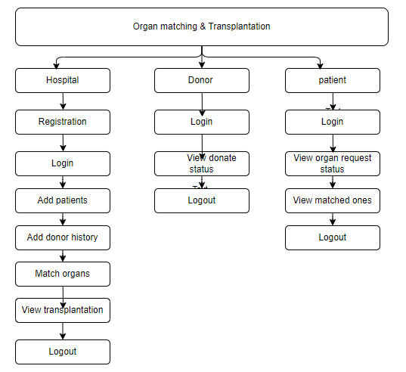

**4. REQUIREMENT ANALYSIS**

**4.1 Functional and non-functional requirements**

Requirement’s analysis is very critical process that enables the success of a system or software project to be assessed. Requirements are generally split into two types: Functional and non-functional requirements.

**Functional Requirements**: These are the requirements that the end user specifically demands as basic facilities that the system should offer. All these functionalities need to be necessarily incorporated into the system as a part of the contract. These are represented or stated in the form of input to be given to the system, the operation performed and the output expected. They are basically the requirements stated by the user which one can see directly in the final product, unlike the non-functional requirements.

Examples of functional requirements:

1. Authentication of user whenever he/she logs into the system
2. System shutdown in case of a cyber-attack
3. A verification email is sent to user whenever he/she register for the first time on some software system.

**Non-functional requirements**: These are basically the quality constraints that the system must satisfy according to the project contract. The priority or extent to which these factors are implemented varies from one project to other. They are also called non-behavioral requirements.  
They basically deal with issues like:

* Portability
* Security
* Maintainability
* Reliability
* Scalability
* Performance
* Reusability
* Flexibility

Examples of non-functional requirements:

1. Emails should be sent with a latency of no greater than 12 hours from such an activity.
2. The processing of each request should be done within 10 seconds
3. The site should load in 3 seconds whenever of simultaneous users are > 10000
   1. **Hardware Requirements**

# Processor - I3/Intel Processor

Hard Disk - 160GB

Key Board - Standard Windows Keyboard

Mouse - Two or Three Button Mouse

Monitor - SVGA

RAM - 8GB

* 1. **Software Requirements:**

Operating System : Windows 7/8/10

Server side Script : HTML, CSS, Bootstrap & JS

Programming Language : Python

Libraries : Flask, Pandas, Mysql.connector, Os, Smtplib, Numpy

IDE/Workbench : PyCharm

Technology : Python 3.6+

Server Deployment : Xampp Server

Database : MySQL

* 1. **Architecture:**

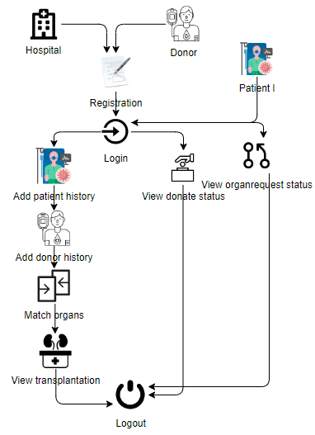

**5. SYSTEM DESIGN**

**5.1 Introduction of Input Design:**

In an information system, input is the raw data that is processed to produce output. During the input design, the developers must consider the input devices such as PC, MICR, OMR, etc.

Therefore, the quality of system input determines the quality of system output. Well-designed input forms and screens have following properties −

* It should serve specific purpose effectively such as storing, recording, and retrieving the information.
* It ensures proper completion with accuracy.
* It should be easy to fill and straightforward.
* It should focus on user’s attention, consistency, and simplicity.
* All these objectives are obtained using the knowledge of basic design principles regarding −
  + What are the inputs needed for the system?
  + How end users respond to different elements of forms and screens.

### **Objectives for Input Design:**

The objectives of input design are −

* To design data entry and input procedures
* To reduce input volume
* To design source documents for data capture or devise other data capture methods
* To design input data records, data entry screens, user interface screens, etc.
* To use validation checks and develop effective input controls.

**Output Design:**

The design of output is the most important task of any system. During output design, developers identify the type of outputs needed, and consider the necessary output controls and prototype report layouts.

### Objectives of Output Design:

The objectives of input design are:

* To develop output design that serves the intended purpose and eliminates the production of unwanted output.
* To develop the output design that meets the end user’s requirements.
* To deliver the appropriate quantity of output.
* To form the output in appropriate format and direct it to the right person.
* To make the output available on time for making good decisions.

**5.2 UML Diagrams:**

**5.2.1 Use Case Diagram:**

A use case diagram in the Unified Modeling Language (UML) is a type of behavioral diagram defined by and created from a Use-case analysis. Its purpose is to present a graphical overview of the functionality provided by a system in terms of actors, their goals (represented as use cases), and any dependencies between those use cases. The main purpose of a use case diagram is to show what system functions are performed for which actor. Roles of the actors in the system can be depicted.

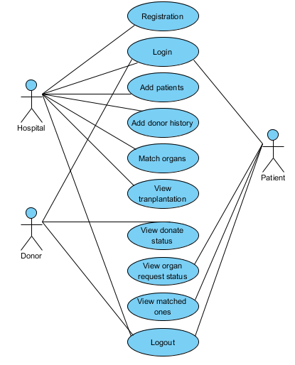

**5.2.2 Class Diagram:**

In software engineering, a class diagram in the Unified Modelling Language (UML) is a type of static structure diagram that describes the structure of a system by showing the system's classes, their attributes, operations (or methods), and the relationships among the classes. It explains which class contains information.

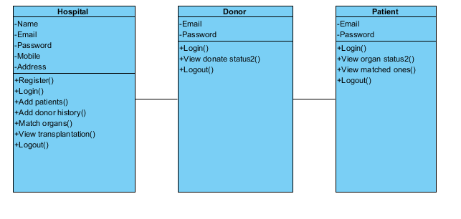

**5.2.3 Sequence Diagram:**

A sequence diagram in Unified Modelling Language (UML) is a kind of interaction diagram that shows how processes operate with one another and in what order. It is a construct of a Message Sequence Chart. Sequence diagrams are sometimes called event diagrams, event scenarios, and timing diagrams.

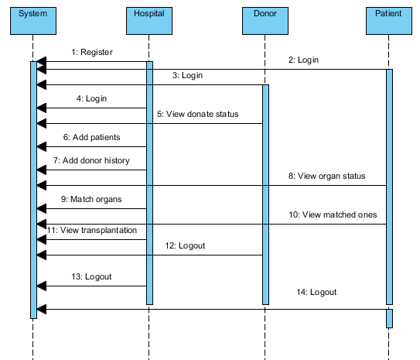

**5.2.4 Collaboration Diagram:**

In collaboration diagram the method call sequence is indicated by some numbering technique as shown below. The number indicates how the methods are called one after another. We have taken the same order management system to describe the collaboration diagram. The method calls are similar to that of a sequence diagram. But the difference is that the sequence diagram does not describe the object organization whereas the collaboration diagram shows the object organization.

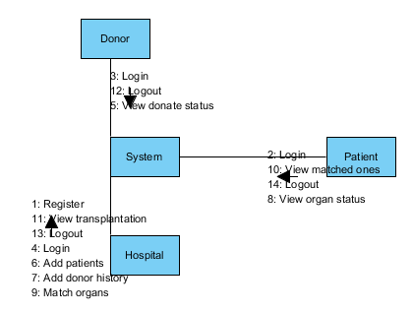

**5.2.5 Deployment Diagram**

Deployment diagram represents the deployment view of a system. It is related to the component diagram. Because the components are deployed using the deployment diagrams. A deployment diagram consists of nodes. Nodes are nothing but physical hardware’s used to deploy the application.

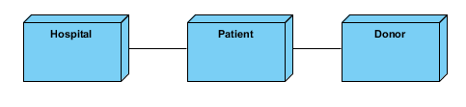

**5.2.6 Activity Diagram:**

Activity diagrams are graphical representations of workflows of stepwise activities and actions with support for choice, iteration and concurrency. In the Unified Modelling Language, activity diagrams can be used to describe the business and operational step-by-step workflows of components in a system. An activity diagram shows the overall flow of control.

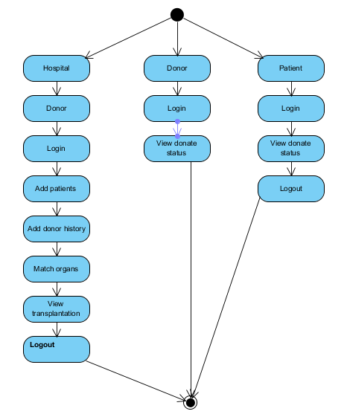

**5.2.7 Component Diagram**:

A component diagram, also known as a UML component diagram, describes the organization and wiring of the physical **c**omponents in a system. Component diagrams are often drawn to help model implementation details and double-check that every aspect of the system's required functions is covered by planned development.

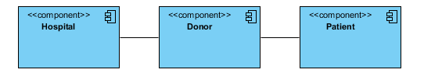

**5.2.8 ER Diagram:**

An Entity–relationship model (ER model) describes the structure of a database with the help of a diagram, which is known as Entity Relationship Diagram (ER Diagram). An ER model is a design or blueprint of a database that can later be implemented as a database. The main components of E-R model are: entity set and relationship set.

An ER diagram shows the relationship among entity sets. An entity set is a group of similar entities and these entities can have attributes. In terms of DBMS, an entity is a table or attribute of a table in database, so by showing relationship among tables and their attributes, ER diagram shows the complete logical structure of a database. Let’s have a look at a simple ER diagram to understand this concept.

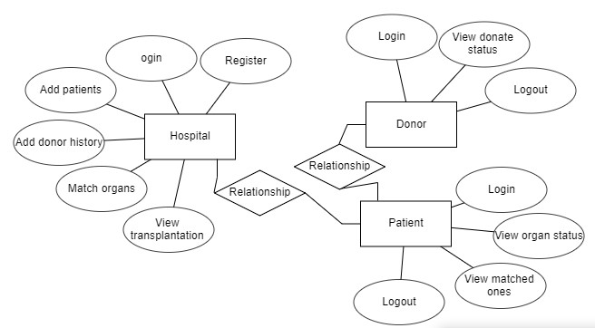

**5.3 DFD Diagram:**

A Data Flow Diagram (DFD) is a traditional way to visualize the information flows within a system. A neat and clear DFD can depict a good amount of the system requirements graphically. It can be manual, automated, or a combination of both. It shows how information enters and leaves the system, what changes the information and where information is stored. The purpose of a DFD is to show the scope and boundaries of a system as a whole. It may be used as a communications tool between a systems analyst and any person who plays a part in the system that acts as the starting point for redesigning a system.

**Level 1 Diagram:**

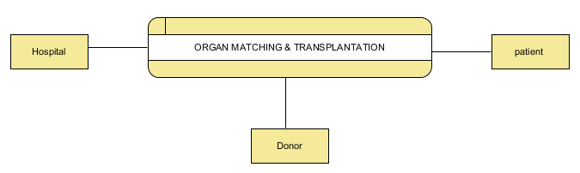

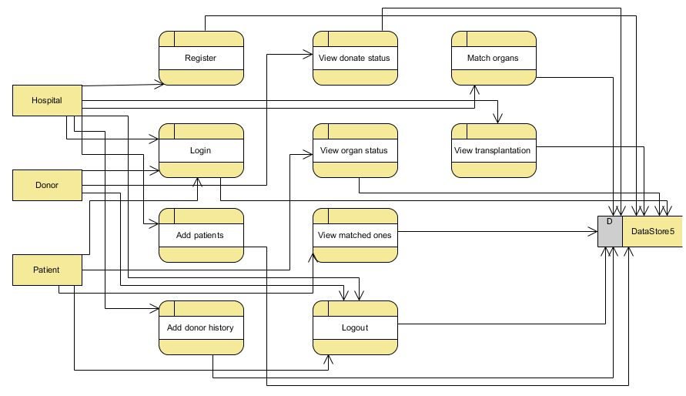

**Level 2 Diagram:**

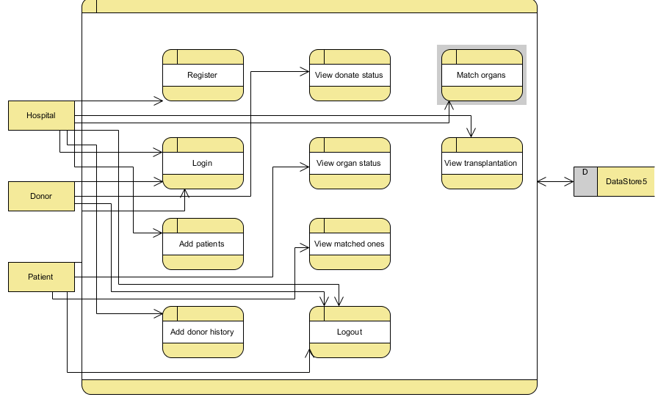

**6. IMPLEMENTATION**

**6.1 Modules:**

**Hospital Module:**

Register: The hospital needs to register with providing valid information.

Login: The hospital can login with using credentials.

Add patients: The hospital has an ability to add the patients.

Add donor history: The hospital has an ability to add the history of donors.

Match organs: Now the hospital have an ability to match the organs.

View transplantation: The hospital can view the transplantation details.

Logout: The hospital should be logout.

**Donor Module:**

Login: The donor can login with using valid credentials.

View donates status: The donor can view the status of donation.

Logout: The donor should be logout.

**Patient Module:**

Login: The patient can login with using valid credentials.

View organ status: The patient can view the status of organs

Match organs: Now the hospital have an ability to match the organs.

Logout: The patient should be logout.

**7. SYSTEM STUDY AND TESTING**

**7.1 Feasibility Study**

The feasibility of the project is analysed in this phase and business proposal is put forth with a very general plan for the project and some cost estimates. During system analysis the feasibility study of the proposed system is to be carried out. This is to ensure that the proposed system is not a burden to the company. For feasibility analysis, some understanding of the major requirements for the system is essential.

Three key considerations involved in the feasibility analysis are

* Economical feasibility
* Technical feasibility
* Social feasibility

**Economical Feasibility**

This study is carried out to check the economic impact that the system will have on the organization. The amount of fund that the company can pour into the research and development of the system is limited. The expenditures must be justified. Thus the developed system as well within the budget and this was achieved because most of the technologies used are freely available. Only the customized products had to be purchased.

### **Technical Feasibility**

This study is carried out to check the technical feasibility, that is, the technical requirements of the system. Any system developed must not have a high demand on the available technical resources. This will lead to high demands on the available technical resources. This will lead to high demands being placed on the client. The developed system must have a modest requirement, as only minimal or null changes are required for implementing this system.

**Social Feasibility**

The aspect of study is to check the level of acceptance of the system by the user. This includes the process of training the user to use the system efficiently. The user must not feel threatened by the system, instead must accept it as a necessity. The level of acceptance by the users solely depends on the methods that are employed to educate the user about the system and to make him familiar with it. His level of confidence must be raised so that he is also able to make some constructive criticism, which is welcomed, as he is the final user of the system.

**System Testing**

The purpose of testing is to discover errors. Testing is the process of trying to discover every conceivable fault or weakness in a work product. It provides a way to check the functionality of components, sub-assemblies, assemblies and/or a finished product It is the process of exercising software with the intent of ensuring that the

Software system meets its requirements and user expectations and does not fail in an unacceptable manner. There are various types of test. Each test type addresses a specific testing requirement.

**7.2 Types of Tests**

**7.2.1 Unit testing**

Unit testing involves the design of test cases that validate that the internal program logic is functioning properly, and that program inputs produce valid outputs. All decision branches and internal code flow should be validated. It is the testing of individual software units of the application .it is done after the completion of an individual unit before integration. This is a structural testing, that relies on knowledge of its construction and is invasive. Unit tests perform basic tests at component level and test a specific business process, application, and/or system configuration. Unit tests ensure that each unique path of a business process performs accurately to the documented specifications and contains clearly defined inputs and expected results.

**7.2.2 Integration testing**

Integration tests are designed to test integrated software components to determine if they actually run as one program. Testing is event driven and is more concerned with the basic outcome of screens or fields. Integration tests demonstrate that although the components were individually satisfaction, as shown by successfully unit testing, the combination of components is correct and consistent. Integration testing is specifically aimed at exposing the problems that arise from the combination of components.

Software integration testing is the incremental integration testing of two or more integrated software components on a single platform to produce failures caused by interface defects.

The task of the integration test is to check that components or software applications, e.g. components in a software system or – one step up – software applications at the company level – interact without error.

**Test Results:** All the test cases mentioned above passed successfully. No defects encountered.

**Acceptance Testing**

User Acceptance Testing is a critical phase of any project and requires significant participation by the end user. It also ensures that the system meets the functional requirements.

**Test Results:** All the test cases mentioned above passed successfully. No defects encountered.

**7.2.3 Functional testing**

Functional tests provide systematic demonstrations that functions tested are available as specified by the business and technical requirements, system documentation, and user manuals.

Functional testing is centered on the following items:

Valid Input : identified classes of valid input must be accepted.

Invalid Input : identified classes of invalid input must be rejected.

Functions : identified functions must be exercised.

Output : identified classes of application outputs must be exercised.

Systems/Procedures: interfacing systems or procedures must be invoked.

Organization and preparation of functional tests is focused on requirements, key functions, or special test cases. In addition, systematic coverage pertaining to identify Business process flows; data fields, predefined processes, and successive processes must be considered for testing. Before functional testing is complete, additional tests are identified and the effective value of current tests is determined.

**7.2.4 White Box Testing**

White Box Testing is a testing in which in which the software tester has knowledge of the inner workings, structure and language of the software, or at least its purpose. It is purpose. It is used to test areas that cannot be reached from a black box level.

**7.2.5 Black Box Testing**

Black Box Testing is testing the software without any knowledge of the inner workings, structure or language of the module being tested. Black box tests, as most other kinds of tests, must be written from a definitive source document, such as specification or requirements document. It is a testing in which the software under test is treated, as a black box .you cannot “see” into it. The test provides inputs and responds to outputs without considering how the software works.

**Test objectives**

* All field entries must work properly.
* Pages must be activated from the identified link.
* The entry screen, messages and responses must not be delayed.

**Features to be tested**

* Verify that the entries are of the correct format
* No duplicate entries should be allowed
* All links should take the user to the correct page**.**

1. **CONCLUSION:**

In conclusion, our project harnesses the power of Blockchain technology to revolutionize the management of hospital, donor, and patient data, addressing critical issues associated with centralized systems. By leveraging the inherent features of Blockchain, including data encryption, immutability, and decentralized storage, we ensure the security, transparency, and resilience of healthcare data management.The future enhancements outlined above will further enhance the capabilities and reach of our system, promoting interoperability, scalability, and improved user experiences. As healthcare institutions embrace Blockchain technology, we are on the path to creating a more secure and efficient healthcare ecosystem, where patients, donors, and healthcare providers can rely on a tamper-proof and transparent platform.In summary, our project represents a significant step towards ensuring the integrity and privacy of sensitive healthcare data while optimizing organ donor-patient matching processes, ultimately leading to improved patient care and increased opportunities for organ transplantation.

**9. FUTURE ENHANCEMENT**

1. Interoperability: We aim to enhance the interoperability of our system by allowing data sharing and access across multiple healthcare institutions. This will facilitate the seamless exchange of patient records and donor information, improving the overall efficiency of healthcare services.

2. Enhanced User Experience: To make the system more user-friendly, we plan to develop user-friendly interfaces and mobile applications for both hospitals and users/donors. This will enhance accessibility and provide real-time updates on matched statuses and other relevant information.

3. Scalability: As more hospitals and healthcare providers join our Blockchain network, we will need to ensure scalability. We will explore solutions like sharding or sidechains to accommodate a growing number of users and data transactions.

4. Data Analytics: Incorporating data analytics tools will enable hospitals to gain valuable insights from the accumulated data. Hospitals can use this information for research, improving patient care, and optimizing donor-patient matching algorithms.

5. Cross-Border Compatibility: Expanding the system's compatibility across international borders will allow for a more extensive donor pool and potentially save more lives. This will involve addressing legal and regulatory challenges related to healthcare data sharing and organ transplantation.

**10.REFERANCES**

1.L. A. Dajim, S. A. Al-Farras, B. S. Al-Shahrani, A. A. Al-Zuraib and R. M. Mathew, "Organ donation decentralized application using blockchain technology", *Proceedings of the 2nd International Conference on Computer Applications & Information Security (ICCAIS)*, May 2019.

2.P. Ranjan, S. Singh, S. Agrawal and V. K. Singh, "Decentralized and distributed system for organ/tissue donation and transplantation", *2019 IEEE Conference on Information and Communication Technology (ICT)*, 2019, July.

3.U. Jain, "Using blockchain technology for the organ procurement and transplant network" in San Jose State University, San Jose, CA, USA, March 2020.

4.B. G. Pillai, J. A. Madhurya, D. Lal and J. Jecob, "An effective protection of data for Organ Donation using Blockchain Technology", *International Journal of Electrical Engineering and Technology (IJEET)*, vol. 11, no. 5, pp. 73-82, July 2020.

5.P. L. Wijayathilaka, U. N. Rajapaksha, H. C. Perera and T. M. Kodikara, "Secured intelligent blood and organ donation management system-'Life Share", *2020 2nd International Conference on Advancements in Computing (ICAC)*, 2020, December.

6.Organ Donation Facts and Info: Organ Transplants, [online] Available: https://my.clevelandclinic.org/health/.

7.Organ Procurement and Transplantation Network.

8.A. Soni and S. G. Kumar, "Creating Organ Donation System with Blockchain Technology", *European Journal of Molecular & Clinical Medicine*, vol. 8, no. 03, June 2021.

9.*OrganProcurementandTransplantationNetwork*,[online]Available: https://optn.transplant.hrsa.gov/governance/publiccomment/standardize-organ-coding-and-tracking-system/.

10.A. Soni and S. G. Kumar, "Creating organ donation system with blockchain technology", *European Journal of Molecular & Clinical Medicine*, vol. 8, no. 3, pp. 2387-2395, 2021.